SECTION 134 NOTICE
Date: 09 June 2026
To,
Mr./Mrs. Jafar Rahim Shaikh
Address: Pension Pura, House No.
8-162, Tal. Ambejogai, Beed
Sub: Request for submission of documents under Section 134 of the Motor Vehicles Act in respect of MACT Claim Investigation
Policy No: POCMVM10100047610
Vehicle No: MH -44-D-5844
Claim/MACT Case No: 2774340
Insurance Company: SBI General Insurance Company Ltd
Dear Sir/Madam,
We, Shovel Screening Solutions Pvt. Ltd., acting on behalf of the Insurance Company, are conducting an investigation in connection with the above-referred motor accident claim case.
You are hereby requested to provide the following documents and information relating to the insured vehicle and accident within 7 days of receipt of this notice:
- Registration Certificate (RC) of the vehicle.
- Driving Licence of the driver involved in the accident.
- Insurance Policy copy.
- Permit, Fitness Certificate and PUC (where applicable).
- Driver's details and contact number.
- Copy of FIR/Charge Sheet, if available.
- Any photographs, videos or other records pertaining to the accident.
- Any other relevant documents relating to the accident and claim.
Your cooperation is solicited for completion of the investigation. In case of non-submission of the requested documents, the same shall be reported to the concerned Insurance Company and may be placed before the Hon'ble MACT as deemed necessary.
Thanking you,
Yours faithfully,
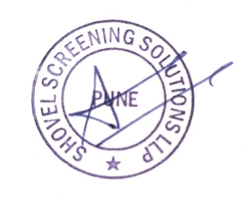
For Shovel Screening Solutions Pvt. Ltd.
(Authorized Investigator on behalf of SBI General Insurance Company Ltd)

Name: Amit Dalvi
Designation: Field Manager
Mobile: 9987268218
Email: amit.dalvi@shovelsolutions.in

